# PeopleSafe - CVS Specialty Copay Plan Design Strategies

Information

Specialty Copay Claim Adjudication

Frequently Asked Questions and Answers

PrudentRx Specific FAQ’s

Related Documents

**Description:** Information about the CVS Specialty Copay Plan Design Strategies, True Accumulation and the PrudentRx solution and varies by client.

|  |
| --- |
| Information |

Specialty Copay Plan Design Strategies applies to PBM commercial clients and health plan Administrative Services Only (ASO) groups. ASO is an agreement that companies use when they fund their employee benefit plan but hire a vendor to administer it.

It is available only for Specialty Clients and not all clients participate.

Participating clients’ CIF is updated individually within the **Plan Design Highlights** section under the SpecialtyRx section and the CVS Specialty Copay Card program.

Without the right management strategies, plan members’ use of manufacturer copay coupons can circumvent a client’s plan design and increase overall costs. CVS Health’s Specialty Copay Plan Design Strategies, True Accumulation and the PrudentRx solution, are designed to address these concerns and help clients incrementally manage their specialty pharmacy spend.

**True Accumulation or Maximizer Plans/Policies:**

To provide our Prescription Benefit Management (PBM) clients with a solution that helps account for the impact of copay card programs and maintains plan design integrity, CVS Health has developed the True Accumulation plan design strategy. Our solution ensures only true member cost share (non-third-party dollars) is applied toward deductibles or out-of-pocket (OOP) maximums, unless otherwise required by law.

The automated accumulator functionality with CVS Specialty will help ensure only true member cost share is applied to any accumulator when specialty copay cards are billed. As an example, if a member's benefit design requires a $100 specialty copay and the member uses a manufacturer copay card of $95, the only amount counted towards any accumulator would be the true OOP cost of $5 the member paid.

A client-owned onsite pharmacy included in a client’s Exclusive Specialty network can be included in the True Accumulation program. Additional steps will be required of the pharmacy to accommodate data sharing. We have options for additional expansion for non-CVS Specialty pharmacies for clients in states with anti-affiliate steerage or AWP requirements. This is still within an exclusive network. Clients cannot have a fully open pharmacy arrangement. Refer to [Specialty Drug Reference Table - Includes Limited Distribution Drugs (LDD) (004448)](https://thesource.cvshealth.com/nuxeo/thesource/#!/view?docid=8239b47a-27ed-48bd-babe-f67c7dd0bb6d)

**The PrudentRx solution**:

We have chosen to collaborate with our vendor, PrudentRx, exclusively for the program. PrudentRx is integrated with our pharmacy operations to help ensure seamless member experience. PrudentRx is a sub-contractor of CVS Health included in the Point Solutions Management (PSM) process.

PrudentRx was founded by individuals who collectively have more than 30 years of experience in the health care and specialty pharmacy industry. Their expertise in plan design, specialty pharmacy, and copay card programs has allowed them to customize a solution that optimizes savings for both members and plan sponsors exclusively for CVS Health.

PrudentRx can help support members requiring specialty medications and exemplifies the CVS Health commitment to both sound business practices and to the communities we serve. They are not a subsidiary of CVS Health.

A PrudentRx advocate supports the member throughout the process and can assist them with obtaining and enrolling in available manufacturer assistance programs, assisting members with questions or concerns, providing ongoing commitment to retrospective claims monitoring, and integrates with the dispensing pharmacy to avoid delays in delivery.

The program is designed for clients who can choose to incorporate it into their plan design.

Members can opt-out of the program, if desired. Currently, 99.9% of members remain opted into the PrudentRx solution. PrudentRx Analytics, January 2022. Data is based on members eligible for the PrudentRx program. P1011420222

This innovative plan design includes all specialty medications on a client’s Specialty Drug List, as well as select high-cost specialty limited distribution drugs (LDDs), regardless of manufacturer assistance availability, to help drive value for clients while participating members have $0 out-of-pocket (OOP) costs*.

Personalized, integrated outreach helps to ensure a best-in-class experience for members. The PrudentRx solution helps provide value for clients and reduce specialty spend, while delivering savings to members by:

* Maintaining plan design integrity
* Allowing participating members to have $0 OOP costs*
* Ensuring a seamless member experience

*Participating members enrolled in High Deductible Health Plans (HDHPs) with Health Savings Accounts (HSAs) must fully satisfy their deductible before they are eligible for a $0 OOP, unless the member has been prescribed medication that qualifies as “preventive care” under IRS statutes for HDHPs with HSAs.

The framework for the PrudentRx solution’s plan design utilizes the Affordable Care Act (ACA) standards for essential health benefits (EHB) and maximum OOP limits. State benchmarks categorize drug classifications and the required number of drugs to be considered EHB. The program uses the Utah state benchmark. The Utah state benchmark includes a limited number of specialty drugs that allows for more flexibility. Clients cannot pick a different benchmark.

This solution has unique enrollment requirements, including a 30% coinsurance for all specialty drugs included in a covered class listed within the program drug list, Exclusive Specialty (with no grace fills), Advanced Control Specialty Formulary, True Accumulation, plan design change, summary plan design (SPD) update, exception process and member mailing.

We will provide clients with sample SPD language. Clients with a custom formulary may also be able to adopt the program after an evaluation.

A client-owned onsite pharmacy included in a client’s Exclusive Specialty network can be included in the PrudentRx program. Additional steps will be required of the pharmacy to accommodate data sharing and standard process to ensure participating members have a final OOP of $0, subject to certain legal requirements set forth above.

We have options for additional expansion for non-CVS Specialty pharmacies for clients in Any Willing Provider (AWP) states or where anti-affiliate steerage laws exist. This is still within an exclusive network. Clients cannot have a fully open pharmacy arrangement.

**Emergency PrEP/PEP:** If a member is established on a PrEP medication already through Specialty but needs an immediate emergency/after-hours fill at a Retail Pharmacy, a one-time courtesy override can be entered to allow the member to bypass Exclusive Specialty, enabling member to fill at Retail Pharmacy for $0. Emergency PEP medication requiring an immediate/after-hours fill at a Retail Pharmacy can also be provided with a one-time courtesy override to bypass Exclusive Specialty, enabling member to fill at Retail Pharmacy for $0.

Plan may allow 1X Specialty override at retail for HIV medications. Specialty overrides may be limited to 30DS. Always check the CIF to ensure you are following the correct information and process. Refer to CIF “Specialty Plan Design Highlights” section and “Override” section for “Specialty Retail Lock Out” override information.

If “Specialty Retail Lock Out” override is appropriate, allowed by plan and rejected claim is on file, refer to [PeopleSafe - Plan Benefit Overrides (PBO) CCR (024671)](https://thesource.cvshealth.com/nuxeo/thesource/#!/view?docid=f075340f-87ec-41b3-bdeb-16422d0fed0e)for override process.

Previously, the PrudentRx solution was not recommended for clients with HDHPs with HSAs. We have made changes that will enable clients to adopt the PrudentRx solution on their HDHPs with HSAs. Adoption of the PrudentRx solution for client plan benefits with HDHPs with HSAs is expected to be available **January 1, 2023**.

**Note**: The PrudentRx solution for HDHPs with HSAs will require the client to agree to specific terms and conditions outlined within associated contracts, including the limitation of implementing the PrudentRx solution for HDHPs with HSAs within an Exclusive Specialty network (client-owned onsite pharmacies, pharmacies included in the Exclusive+ Specialty Network, and other non-CVS Specialty dispensing pharmacies are **not appropriate** and will **not** be included upon initial availability of the solution for client plan benefits with HDHPs with HSAs). Participating members enrolled in HDHPs with HSAs must fully satisfy their deductible before they are eligible for a $0 OOP, unless the member has been prescribed medication that qualifies as “preventive care” under IRS statutes for HDHPs with HSAs.

Top of the Document

|  |
| --- |
| Specialty Copay Claim Adjudication |

Within **Client Programs Offerings**, it will indicate if client has Specialty Copay Card Program. When a member uses a copay card for a specialty drug filled at a CVS Specialty pharmacy, it ensures only true member cost share (non-third party dollars) are applied towards members accumulations (Deductibles and Out of Pocket).

**Example:** View Financials page in PeopleSafe displays all the pricing information.

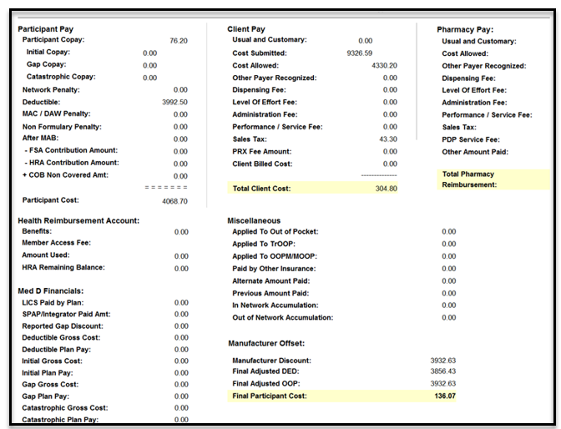

**Example:** Background information - Member initially had $7.50 applied to their $4,000 deductible before this claim example, so when the claim adjudicated, the member was responsible for 100% for the remainder of his deductible ($4,000- $7.50 = $3,992.50).

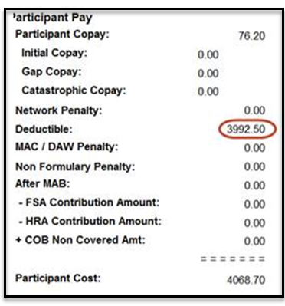

**Participant Pay**

**Example:** Total Cost of the drug was $4,330.20 + $43.30 tax = $4,373.50 (Cost allowed).

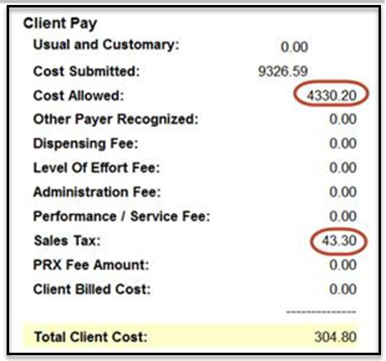

**Client Pay/Cost**

**Example:** The member covers 100% of the remaining deductible ($3,992.50), thus $4,373.50 (Cost allowed plus tax) minus $3,992.50 = $381.00. The member owes 20% of $381.00 as the deductible was met with part of this claim and the plan is 20% coinsurance after the deductible is met.

$381 x .20 = $76.20. $76.20 is the amount owed on top of the remaining deductible. The member in this case will pay $4,068.70 (balance of deductible + 20% coinsurance on balance of claim) before copay assistance is utilized.

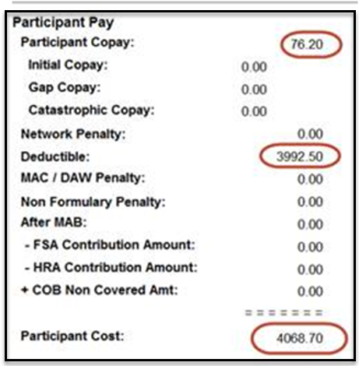

This is before the copay assistance registers. Claims adjudicate as normal as shown above and then the copay program goes into effect and accumulators will adjust. Even though the $3,992.50 does not end up going towards the deductible, it originally adjudicated like normal as if the deductible were presented with this claim.

At the end of this scenario, the copay card is worth $3,932.63. The members’ cost share is $4,068.70 subtracted by $3,932.63 (covered by the copay card) and the member owes $136.07 out of their pocket. The amount $136.07 will apply to the members’ accumulations.

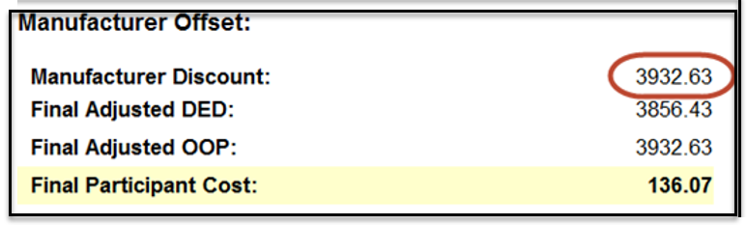

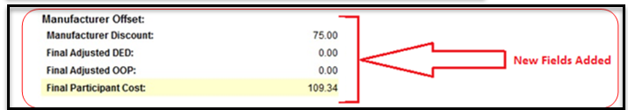

**PeopleSafe screen**

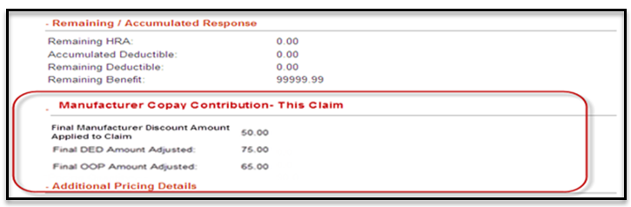

**COS screen**

This is a summary of what you might expect to see in the Account Balance screen when the copay assist card is off setting the appropriate Deductible or MOOP from Pharmacy Claims to Medical Transactions for the exact dollar amount.

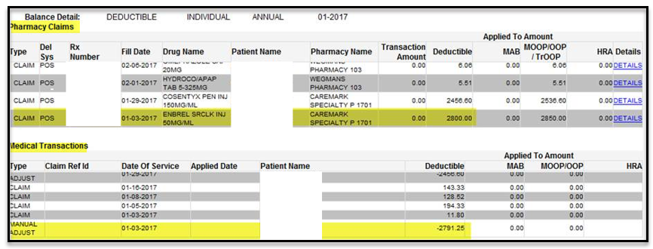

**View Financials screen**

Top of the Document

|  |
| --- |
| Frequently Asked Questions and Answers |

Use as needed:

|  |  |  |  |
| --- | --- | --- | --- |
| **#** | **Question** | **Answer** | |
| **1** | **What is a Specialty Copay Plan Design Strategy?** | Specialty Copay Plan Design Strategies (True Accumulation, Copay Optimization (**sunset as of 12/31/22)**, and the PrudentRx solution)) are a means to identify payments that are made on behalf of the patient by manufacturer copay card for any medication dispensed by CVS Specialty.  True Accumulation ensures that only true member out-of-pocket (OOP) costs are applied to an accumulator (**Example:** Deductible and/or maximum out of pocket MOOP) of our clients enrolled in the program.  True Accumulation and Copay Optimization became effective January 1, 2017. PrudentRx became effective July 1, 2020.  These programs are available only for Exclusive Specialty clients, as not all clients will be participating. Each participating client implementation form (CIF) is updated individually.  These strategies help clients maintain the integrity of their plan design and manage specialty drug spend. The third party-sponsored copay cards are directed towards the commercially insured members (copay cards used with members who have a financial need or hardship are not included as part of this program).  The copay cards directed at the commercially insured are used to reduce or eliminate a plan member’s out-of-pocket cost for specific drugs and to create brand loyalty.  While copay cards may reduce individual members’ immediate cost savings, copay cards affect clients in several ways including Copay Cards circumvent the effectiveness of a tiered benefit design in instances where a member has a pharmacy only or an integrated pharmacy/medical accumulator (includes out-of-pocket and or deductible), the member’s responsibility and engagement is reduced as accumulators are reached using the copay card dollars obtained. | |
| **2** | **How does this program work?** | To provide our prescription benefit management (PBM) clients with the opportunity to help account for the impact of copay card programs and maintain plan design integrity, the PBM has developed Specialty Copay Plan Design Strategies.     1. **True Accumulation:** Automated accumulator functionality with CVS Specialty will help ensure only true member cost share is applied towards any accumulator when specialty copay cards are billed. As an example, if a member's benefit design requires a $100 specialty copay and the member uses a manufacturer copay card of $95, the only amount counted towards any accumulator would be the true OOP cost of $5 the member paid.   Both COS and PeopleSafe have been updated to display any manufacturer discount applied to a claim, along with the Final Deductible amount applied and Final Out of Pocket amount applied.   1. **Copay Optimization Plan Design – sunset as of 12/31/22:** Leverages the value of copay cards for select specialty medications to help maximize program savings for clients. It includes a plan design update at the drug-and therapy levels to the value of the copay cards included in the program.   As an example of the Copay Card Plan Design, if a member’s benefit design today requires a $100 specialty copay when a manufacturer copay card of $750 is offered, the PBM would recommend a plan design change to $750. CVS Specialty bills the available copay assistance program for $750.  The member will then pay the amount required by the copay assistance program, which in many cases is $0, but not more than $50. The Plan will receive the additional $700 in savings on that claim, assuming that the copay assistance program requires that the member pay $50. Overall savings from the program will vary based upon initial plan design parameters and rebate eligibility.   1. **The PrudentRx solution:** We have chosen to collaborate with our vendor, PrudentRx, exclusively for the program. PrudentRx is integrated with our pharmacy operations to help ensure a seamless member experience. PrudentRx is a sub-contractor of CVS Health included in the Point Solutions Management (PSM) process. PrudentRx was founded by individuals who collectively have more than 30 years of experience in the health care and specialty pharmacy industry. Their expertise in plan design, specialty pharmacy, and copay card programs has allowed them to customize a solution that optimizes savings for both members and plan sponsors exclusively for CVS Health. PrudentRx can help support members requiring specialty medications and exemplifies the CVS Health commitment to both sound business practices and to the communities we serve. They are not a subsidiary of CVS Health.   The PrudentRx solution is an innovative plan design that requires all specialty medications in a covered class on a client’s Specialty Drug List, as well as select high-cost specialty limited distribution drugs (LDDs), regardless of manufacturer assistance availability to process with a 30% coinsurance. All eligible members enrollment begins automatically in the program. The member is engaged by a trained PrudentRx advocate to support the member throughout the process and can assist them with obtaining and enrolling in available manufacturer assistance programs; any remaining amount not covered by available manufacturer assistance, if that assistance has been exhausted, or if no assistance is available, will be covered by the plan to ensure a $0 final out of pocket cost* to the participating member.  As an example of the PrudentRx Plan Design, if a member’s 30% coinsurance results in a $750 member cost share, the member enrolls in PrudentRx and a manufacturer copay card of $695 is offered, CVS Specialty bills the available copay assistance program for the $695 and the remaining $55 will be billed as COB to the plan; resulting in the participating member paying $0 out of pocket cost.*  *Participating members enrolled in High Deductible Health Plans (HDHPs) with Health Savings Accounts (HSAs) must fully satisfy their deductible before they are eligible for a $0 OOP, unless the member has been prescribed medication that qualifies as “preventive care” under IRS statutes for HDHPs with HSAs. | |
| **3** | **What is a manufacturer sponsored copay card?** | A third party sponsored copay card (**Example:** Copay card) is a direct-to-consumer incentive manufacturers offer to promote brand loyalty and the use of brand-name pharmaceutical products. The copay cards can also be used to lower Out-of-Pocket costs for eligible patients. | |
| **4** | **Are there several types of copay cards?** | Yes. There are two types of copay card programs offered.   1. **Non-needs based**: The first type of copay card is offered to the commercially insured population. These copay cards may be used regardless of a patient’s financial status and do not require any form of eligibility or qualification to obtain assistance. The focus of the Specialty Copay Plan Design Strategies is the non-needs-based copay cards. 2. **Needs-based/Patient assistance Program:** The second type of copay card is offered is a copay assistance program offered by a manufacturer sponsor or independent non-profit to help patients who meet specific financial eligibility criteria. These patients may be uninsured, underinsured or may have been denied coverage by their commercial plans. | |
| **5** | **How do clients sign up for the program?** | Clients work with their Sales/Account Executive contact to enroll in the program. | |
| **6** | **When viewing the CIF, what indicates the client is participating in this program?** | Adjusted deductible/Maximum Out of Pocket (MOOP) details are visible within the newly added manufacturer offset section of PeopleSafe.  **Note:** The CIF is updated individually within the Plan Design Highlights section under the SpecialtyRx section advising the client participates and the CVS Specialty Copay Card program applies. | |
| **7** | **How do the members of the client participate?** | Once a client is enrolled, the accumulator automatically tracks the true member DED and out-of-pocket costs. | |
| **8** | **Will all the members with the participating client be enrolled?** | While most employer clients enroll at the carrier level, some health plans may enroll at the individual group level and not for the entire plan. | |
| **9** | **How do members typically enroll in a copay card program?** | The member must enroll directly with the copay card program. While the CVS Specialty Pharmacy assists members with enrollment, the enrollment process can vary by copay card, but members can often enroll online. | |
| **10** | **Are there special qualifications for each member to participate within the client group?** | No. | |
| **11** | **Can members using a Medicare Part D or Medicaid Plan use a copay card?** | No. Federal law prohibits Medicare Part D, Medicaid beneficiaries and certain other federally funded plans from using these incentives. | |
| **12** | **How can you tell if a member’s plan sponsor has enrolled in the True Accumulation program?** | Within the Client Programs and Offerings section of PeopleSafe, it indicates which Specialty Copay Plan Design Strategy the client is enrolled in.  If a member has used a copay card, the value of the copay card used is visible in both COS and PeopleSafe.  Both applications have been updated to display any manufacturer discount applied to a claim, along with the Final Deductible amount applied and Final Out of Pocket amount applied. | |
| **13** | **What happens once a member is enrolled in a copay card program?** | The member continues to fill prescriptions as usual. The pharmacy enters the copay assistance details when submitting the claim and the copay assistance is applied by the pharmacy. | |
| **14** | **What is the duration of copay card programs?** | The duration of copay card programs varies by drug. The expiration depends on the parameters outlined by the third-party sponsor providing the copay card. | |
| **15** | **What prescription drugs are offered with copay cards?** | Most copay cards are designed for more expensive specialty prescription drugs. CVS Specialty or PrudentRx can tell you if your medication has a copay card program. | |
| **16** | **How are the funds received?** | Manufacturer copay cards are billed by the specialty pharmacy as a type of COB/secondary claim. Any funding obtained via a manufacturer copay card is automatically applied/used to offset the member’s copay/cost share. | |
| **17** | **What if the incorrect amount was applied to the members account?** | The amount applied to the members’ account is directly tied to the amount of assistance obtained from a manufacturer’s copay card. Incorrect amounts will not be applied. | |
| **18** | **Can the amount be recalled after being applied to the member’s account?** | No | |
| **19** | **Can a copay card still be used if the member’s plan sponsor has elected to enroll in a CVS Specialty Copay Plan Design Strategy and updated their accumulator?** | Yes. The member may continue to use copay cards to help reduce Out of Pocket expenses. However, any amount of support obtained from the copay card will no longer be applied towards the member’s pharmacy only or integrated pharmacy and medical Out-of-Pocket/deductible.  As an example, if a member’s benefit design requires a $100 specialty copay and uses a manufacturer copay card of $95 whereas the true out-of-pocket cost for the member is $5, the only amount counted towards any accumulator would be the true Out-of-Pocket cost of $5 the member paid.  Both COS and PeopleSafe have been updated to display any manufacturer discount applied to a claim, along with the Final Deductible amount applied and Final Out of Pocket amount applied. | |
| **20** | **Why will copay card support no longer be contributed towards a member’s accumulator (out-of-pocket/ deductible)?** | Deductibles are established as a means of cost sharing with your plan sponsor while an Out-of-Pocket maximum is the most you will pay during a policy period.  Assistance obtained through a copay card is provided by the copay card sponsor and does not reflect any actual out-of-pocket cost the member pays. Given that deductibles and Out-of-Pocket maximums are intended to capture true member costs only and not third-party assistance, unless otherwise required by law, through a copay card (not including monthly premium payments), the update to accumulators was made.  Both COS and PeopleSafe have been updated to display true patient out-of-pocket costs along with any manufacturer discount applied to a claim, along with the Final Deductible amount applied and Final Out-of-Pocket amount applied. | |
| **21** | **What happens if a member’s plan sponsor implements the Copay Optimization plan design?** | For plan sponsors implementing the Copay Optimization Plan Design **(new client implementations of Copay Optimization were discontinued effective 5/1/22 and the program will be officially sunset as of 12/31/22)**, the member’s copay will increase for select specialty medicines that offer a copay card.  For impacted specialty medicines, members can obtain support through the copay cards to help lower Out-of-Pocket costs. In many instances when a copay card is used, a member’s final Out-of-Pocket cost will be $50 or less for up to a 30-day supply.  It is important to note that any copay card assistance a member receives will not count towards any deductible or out of pocket. See the example below to learn more. | |
| **Before** | **After** |
| Medicine cost: $2,000 (for a 30-day supply) | Medicine cost: $2,000 (for a 30-day supply) |
| Member copay: $50 | Member copay: $750 |
| Copay card: $45 | Copay card: $745 |
| Cost towards OOP/Deductible: $50 | Cost towards OOP/Deductible: $5 |
| **Member final cost:** $5 | **Member final cost:** $5 |
| **22** | **What is the Customer Care area that will support Copay Cards?** | Benefit Verification/Billing | |
| **23** | **Why didn’t my deductible amount decrease?** | Your insurance received an update that now can recognize non needs based copay card program payments and reflect those as insurance payments instead of deductible or Out-of-Pocket patient payments.  This was done because the amounts that are applied to an insurance deductible and/or maximum Out-of-Pocket is supposed to be reflective of amounts paid by the insured directly. | |
| **24** | **Is this change to my benefit plan retroactive?** | No. Once your insurance is updated with the ability to recognize assistance program payments and reflect those as insurance payments instead of deductible or Out-of-Pocket patient payments, the change will take effect on a go forward basis.  Any previous deductible or out of pocket patient payments will not be adjusted. | |
| **25** | **Do all specialty members use a non-needs-based copay card?** | No. In many instances, members do not use a copay card.  If a copay card is used to offset any cost share, the value of the copay card will **not** be added to your deductible or Out-of-Pocket maximum. | |
| **26** | **Are members required to use a copay card?** | No. Members are not required to participate in a copay card program. If a client is enrolled in a Specialty Copay Plan Design Strategy, enrollment in a copay card program to help offset Out-of-Pocket costs is strongly recommended and should be encouraged. Members should be directed toward the appropriate copay card enrollment process. | |
| **27** | **My specialty copay/cost has increased; can I use a copay card?** | **This question is related only to clients that have Copay Optimization in place.**  Your insurance has increased the cost share/copay for certain specialty medications. Members impacted by this change will have an opportunity to participate in a copay card program to off-set the increased copay/cost share to no more than $25 in many instances.  The CVS Specialty Pharmacy can provide you with the support and resources to help you learn about any available copay card programs and the enrollment process and contacts you once you submit your next prescription or refill. | |
| **28** | **Who can I speak with about the copay card program I am currently using?** | The CVS Specialty Pharmacy can answer questions you have on the copay card.  **CCR:** Warm Transfer the caller to Specialty pharmacy. Refer to [Basic Call Handling (Greet, Warm, Cold, Call Hold and Close Call) (066076)](https://thesource.cvshealth.com/nuxeo/thesource/#!/view?docid=18c64566-0ebb-4760-96fe-04da06185de0)  Let me get you over to our Specialty pharmacy, who will direct you to your correct therapy for further assistance. | |
| **29** | **Is the needs-based foundation/ patient assistance program copay card included as part of this change?** | No. The benefit change applies only to **non-needs-based** copay card programs. The **needs-based** foundation/patient assistance programs are not included as part of the benefit change. | |
| **30** | **Can you tell me how much was contributed towards my deductible/ maximum out of pocket for my last prescription?** | Yes. Accumulator updates are now visible within PeopleSafe and COS. For clients enrolled in the program and have changed their benefit, the manufacturer offset (**Example:** Copay card support) is populated and the final amount of Deductible/Maximum Out-of-Pocket (MOOP) contribution will be listed. | |
| **31** | **Can a member opt out of this program or can an exception be made to have their copay card apply to their accumulators again?** | For True Accumulations and Copay Optimization: A member can choose not to utilize assistance. This way, every penny the member pays gets applied to their accumulation.  **OR**  A member using the assistance card on an insurance/prescription plan is enrolled in the program. Members cannot opt out; they have the option to present/advise the pharmacy to use the copay card.  For the PrudentRx solution:All eligible members’ enrollment begins automatically in the program, but members can choose to opt-out at any time. Members must call **1-800-578-4403** to opt out.  Some manufacturers require members to sign up to take advantage of the copay assistance that they provide for their medications in that case; members must speak to someone at PrudentRx at **1-800-578-4403** to provide any additional information needed to enroll in the copay program.  A trained PrudentRx advocate contacts members if they are required to enroll in the copay assistance for any medication that they take.   * If members choose to opt-out of the program, or if they do not affirmatively enroll in any available copay assistance as required by a manufacturer, they will be responsible for the full amount of the 30% co-insurance on specialty medications that are eligible for the PrudentRx program. * If a drug is listed as non-EHB, member cost share payments toward the 30% coinsurance will not count toward the Plan’s MOOP, unless otherwise required by law and the member will be responsible for the 30% coinsurance for non-EHB drugs even after the MOOP is met. | |
| **32** | **Could I exhaust the manufacturer assistance available and potentially must pay more out of pocket on a future fill?** | Any amount received from a non-needs-based manufacturer program does not accumulate toward your Deductible or OOP. Depending on the manufacturer’s yearly maximum card program amounts, that value could be reached by your claims.  At that point, with no other pharmacy or integrated medical claim activity, with no available assistance, you then are responsible for the Deductible and Out of Pocket amounts as defined by the plan you enrolled in. | |
| PrudentRx Specific FAQ’s | | | |
| **#** | **Question/Statement** | **Answer** | |
| **1** | **How does the program work?** | We have chosen to collaborate with our vendor, PrudentRx, exclusively for the program. PrudentRx is integrated with our pharmacy operations to help ensure seamless member experience. A PrudentRx advocate supports the member throughout the process and can assist them with obtaining and enrolling in available manufacturer assistance programs, assisting members with questions or concerns, providing ongoing commitment to retrospective claims monitoring, and integrates with the dispensing pharmacy to avoid delays in delivery.  Once the member is enrolled in the program, the participating member will have a $0 final OOP cost*, regardless of if their specialty therapy has a manufacturer copay card program available. The plan design will be adjusted to a 30% coinsurance for all specialty medications.  *Participating members enrolled in High Deductible Health Plans (HDHPs) with Health Savings Accounts (HSAs) must fully satisfy their deductible before they are eligible for a $0 OOP, unless the member has been prescribed medication that qualifies as “preventive care” under IRS statutes for HDHPs with HSAs. | |
| **2** | **How does this program handle drug categories like HIV and limited distribution drugs (LDD) not available at CVS Specialty?** | For a class like HIV, the drugs will be included in the program if the client includes this as a covered class listed on the PrudentRx program drug list. If they are open network or excluded as specialty products, they will be excluded from the PrudentRx program. Any medication or covered class not included on the PrudentRx program drug list will continue to adjudicate at the plan applicable member cost share. | |
| **3** | **What if members do not want to participate in this plan design strategy?** | For clients that implement the PrudentRx solution, members will be encouraged to remain enrolled in the PrudentRx program. Members who elect to opt out of the program will be responsible for the full 30 percent coinsurance.  If a drug is listed as a non-EHB, member payments toward the 30 percent coinsurance will not count toward the MOOP unless otherwise required by law and the members will be responsible for the 30 percent coinsurance for non-EHB drugs even after the MOOP has been met. | |
| **4** | **What if a member opts out, but then wishes to re-enroll; can they?** | Yes, a member may choose to opt-out at any time and re-enroll at any time. Any claims that process while they are opted out will do so at the 30% coinsurance and the member will be responsible for the 30% if no manufacturer copay card/assistance is utilized, but they are not guaranteed the $0 OOP as they would not be enrolled in PrudentRx. | |
| **5** | **What if a member opts out then asks for an Exception to a Non-Essential Health Benefit?** | For **PrudentRx:** If the member says they have opted out of the program and are requesting an exception to a Non-Essential Health Benefits (EHB designation for their medication, warm transfer to the Senior Team. | |
| **6** | **If a member enrolls in the PrudentRx solution, what is the process for obtaining a specialty copay card and ensuring that it is used when a prescription is submitted?** | For existing members on specialty medications, PrudentRx will send a welcome letter to the member on behalf of the client that provides specific information about the program as it pertains to the member’s medication. PrudentRx will also proactively follow-up with the member via telephone. Member outreach occurs approximately 30 days prior to go-live. PrudentRx continuously monitors copay card utilization and will conduct proactive member outreach as needed.  When a new prescription is received and processed by the pharmacy, there is an administrative process to capture the claim and perform member outreach. From there, CVS Specialty offers to transfer the member to PrudentRx or will provide the member with PrudentRx contact information. Prior Authorization and formulary are not affected by the PrudentRx program.  PrudentRx will enroll the member in the manufacturer copay card program and obtain the necessary manufacturer copay where applicable. This process usually takes less than ten minutes but may take up to five to seven days depending on the manufacturer’s process. The member will be informed through the process. | |
| **7** | **What happens if the specialty copay card is no longer offered?** | Specialty copay cards are monitored on a regular basis to quickly respond to any changes that may impact the member savings.   * If a specialty copay card is no longer being offered, the drug will be adjudicated at 30% coinsurance and participating members’ out of pocket costs will be $0*. * If the member declines enrollment, they are responsible for the 30% coinsurance.   *Participating members enrolled in High Deductible Health Plans (HDHPs) with Health Savings Accounts (HSAs) must fully satisfy their deductible before they are eligible for a $0 OOP, unless the member has been prescribed medication that qualifies as “preventive care” under IRS statutes for HDHPs with HSAs | |
| **8** | **What if a drug does not have a specialty copay card?** | If the member remains enrolled in the PrudentRx solution, the participating member’s OOP cost will be $0.*  *Participating members enrolled in High Deductible Health Plans (HDHPs) with Health Savings Accounts (HSAs) must fully satisfy their deductible before they are eligible for a $0 OOP, unless the member has been prescribed medication that qualifies as “preventive care” under IRS statutes for HDHPs with HSAs | |
| **9** | **What happens if the member maxes out the annual manufacturer assistance available?** | If the member remains enrolled in the PrudentRx solution, the participating member’s OOP cost will be $0.*  *Participating members enrolled in High Deductible Health Plans (HDHPs) with Health Savings Accounts (HSAs) must fully satisfy their deductible before they are eligible for a $0 OOP, unless the member has been prescribed medication that qualifies as “preventive care” under IRS statutes for HDHPs with HSAs | |
| **10** | **What is the difference between EHB and non-EHB drugs?** | Under the ACA, non-grandfathered, self-funded plans are not required to cover EHB, but they are subject to annual maximum out-of-pocket (MOOP) limits. Covered benefits that fall outside the authorized definition are deemed non-EHB and need not be counted toward a member’s MOOP limit. In the PrudentRx solution, non-EHB drugs are included in the program, and may still be covered by the plan; however, the 30% coinsurance will not apply toward the MOOP. | |
| **11** | **What are PrudentRx hours of operation and what language services do they offer?** | PrudentRx offers direct member support and their specially trained customer care advocates are available Monday-Friday 8 am to 8 pm EST. They offer Spanish-speaking advocates as well as language services to accommodate members whose primary language is not English. Members can be encouraged to call PrudentRx at **1-800-578-4403** orEmail [info@prudentrx.com](mailto:info@prudentrx.com) for further requested information. | |

Top of the Document

|  |
| --- |
| Related Documents |

[Customer Care Abbreviations and Definitions and Terms Index (017428)](https://thesource.cvshealth.com/nuxeo/thesource/#!/view?docid=c1f1028b-e42c-4b4f-a4cf-cc0b42c91606)

Top of the Document

Not to Be Reproduced or Disclosed to Others without Prior Written Approval

**ELECTRONIC DATA = OFFICIAL VERSION / PAPER COPY = INFORMATIONAL ONLY**